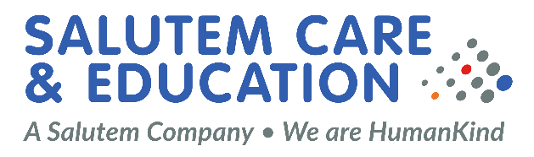

Job Description

Job Title: HR Administrator

Reporting To: Senior HR Administrator

Location: Windsor/Hybrid

Job Overview
As HR Administrator you are a key member of the HR and Recruitment team, and you will support the Senior HR Administrator to offer the managers an effective HR Administrator service. You will manage the onboarding process from the point of offer accepted for candidates across all divisions using our ATS. You will conduct compliance checks, arrange for all reference requests, and chase any outstanding, complete DBS processes, complete contracts and all other onboarding activity. You will ensure safer recruitment guidance is followed at all times to enable new starters to join as swiftly as possible with full compliance. Your role also supports the wider HR team with admin tasks which include contractual amends, maternity, paternity, adoption and shared parental leave Administrator, references, requests for documents, audits, minute talking, completing actions via our HR & Payroll system and will be part of the team managing the inbox, dealing with queries with support from the Senior HR Administrator.
This role is line managed by the Senior HR Admin

Job Responsibilities:
- Deliver efficient onboarding to your designated Division onboarding a minimum amount of new starters and compliance % as agreed in KPI’s.
- Support the organisation with admin support when needed, including the preparation and processing of various payroll changes etc.
- Take ownership of the inbox actioning items within our SLA’s taking advice from the Senior HR Admin where appropriate
- Complete contracts and contractual amends and ensure they are issued and returned as signed and filed appropriately.
- Complete reference requests.
- Assist the HR team with audits.
- Develop and maintain good working relationships across our organisation.
- ensure all onboarding activities are managed (via the applicant tracking system) from offer acceptance to start date and that files are produced in a compliant format across the Senior.
- Ensure compliance for the onboarding of all overseas workers.
- Ensure all checks and processes are completed for all new hires including references, DBS, right to work, medical questionnaires ensuring that the appropriate risk assessments are in place where necessary.
- Ensure the new starter file/information is transferred to payroll in a timely manner to enable them to be included in the appropriate payroll.
- Ensure the new starter file/information is checked by The HR Administrator for final sign off prior to start date and then transferred to the service locations as appropriate.
- Keep up to date with legislation changes within the HR and Recruitment space.
- Ensure that all onboarding activity is run in line with safeguarding for children and vulnerable adults.
- Ensure HR & Payroll system admin tasks are completed within agreed deadlines.
- Have excellent organisational skills and the ability to prioritise workload.
This job description should not be seen as all encompassing, and the post holder will be expected to undertake any other responsibilities appropriate to the post as identified by the company.

Our Values
-We are Supportive by promoting opportunities for everyone so they can reach their full potential
-We are very Ambitious to provide the best possible outcomes for the people who use our services
-We are Loyal because we put the people that we support and our staff at the centre of everything we do, and we deliver on our promises. We also are committed to ensuring that our services are meeting the needs of all stakeholders
-We are Unique because we are ambitious and innovative about the diversity of the services that we provide without compromising quality
-We are Transparent by being open, honest and fostering a culture of mutual respect. We promote a culture where we learn by our experiences, and we are committed to doing things better and setting the highest standards in what we do
-We are Engaging because we work in partnership with the people that we support, our staff and all our stakeholders
-We encourage everyone to experience a Meaningful life by being aspirational and by offering opportunities

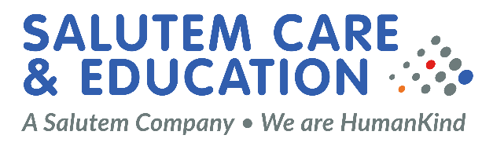

Knowledge, skills and competency
Area | Essential | Desirable
Professional Qualifications | Demonstrable experience within a HR or recruitment admin role
Knowledge | Excellent Administrator skills in full Microsoft office suite
Skills | Excellent communication both written and oral
Experience | Demonstrable experience delivering HR and Recruitment documents. | Demonstrable experience delivering HR and Recruitment documents
Personal Qualities | Committed to achieving goals with a tenacious approach to delivery and quality of output.
Other | -Attention to detail, compliance and accuracy is paramount  -Excellent communication and interpersonal skills, with the ability to get things done in co-operation with others, and as part of a team.  - Ability to work under pressure at times and effective at working to deadlines.  - Ability to work autonomously with an eye for details as well as in a team.  - Ability to use discretion and maintain confidentiality.  - Flexibility.  - Proactive, personable and dynamic.

